Project Report: FlightFinder – Navigating Your Air Travel Options

**1. INTRODUCTION**

**1.1 Project Overview**

FlightFinder is a web-based flight booking system that helps users search, compare, and book flights conveniently. It provides real-time flight details, a smooth booking process, and user account management, along with an admin panel to manage flight data.

**1.2 Purpose**

The purpose of FlightFinder is to simplify air travel booking by bringing all airline and route options onto a single, easy-to-use platform, saving time and improving the booking experience for travelers.

**2. IDEATION PHASE**

**2.1 Problem Statement**

Travelers struggle with multiple airline sites, hidden charges, and confusing booking flows. Existing systems lack transparency and ease of use. FlightFinder aims to solve this by providing a unified, user-friendly solution for air travel booking.

**2.2 Empathy Map Canvas**

**Who are the users?**: Frequent travelers, students, business professionals, tourists.

**What do they think and feel?**: Want hassle-free booking, reliable info, transparent prices.

**What do they say and do?**: Compare prices on different sites, check multiple sources for best deals.

**What do they hear?:** Recommendations from friends, online reviews.

**Pain Points**: Wasting time on multiple sites, fear of hidden charges, booking errors.

**Gain**: A smooth, trustworthy platform for booking flights easily.

**2.3 Brainstorming**

Ideas generated include:

1.Integrating multiple airlines

2.Providing filters for routes, dates, and fare range

3.Booking confirmation and e-ticket generation

4.Admin panel for managing flights

5.Possible add-ons: fare prediction, personalized offers.

**3. REQUIREMENT ANALYSIS**

**3.1 Customer Journey Map**

1. User visits website

2. Registers/Logs in

3. Searches flights by source, destination, and date

4. Views available options

5. Compares fares

6. Books a flight

7. Receives booking confirmation

8. Admin manages flight data in backend

**3.2 Solution Requirement**

Functional:

User login/registration

Flight search & filter

Booking module

Booking history

Admin module to manage flights

Non-Functional:

Secure login

Fast response time

User-friendly UI

Scalable backend

**3.3 Data Flow Diagram**

Level 0: User → Frontend → Backend API → Database

Level 1: User requests → Search Flights → Display Options → Booking → Update DB → Confirmation

**3.4 Technology Stack**

Frontend: HTML, CSS, JavaScript (React.js optional)

Backend: Node.js, Express.js

Database: MongoDB

Tools: GitHub, Postman

**4. PROJECT DESIGN**

**4.1 Problem Solution Fit**

The proposed system addresses the problem by combining real-time search, simple booking, and admin management into a single application.

**4.2 Proposed Solution**

A responsive web app where users can search flights, compare prices, and book tickets easily. Admins can update flights, check bookings, and manage system data.

**4.3 Solution Architecture**

User Interface: Frontend with search and booking forms.

Backend: Node.js REST API.

Database: MongoDB for storing flights, users, bookings.

Admin Panel: Secured routes for CRUD operations.

---

**5. PROJECT PLANNING & SCHEDULING**

**5.1 Project Planning**

Week 1: Requirement gathering & wireframe design

Week 2: Frontend development

Week 3: Backend API & database integration

Week 4: Testing & bug fixing

Week 5: UAT & final deployment

**6. FUNCTIONAL AND PERFORMANCE TESTING**

**6.1 Performance Testing**

Load tested for multiple concurrent users searching flights.

Average search response time: < 3 seconds.

Booking response time: < 2 seconds.

Admin CRUD operations tested for accuracy.

**7. RESULTS**

**7.1 Output Screenshots**

Home page with flight search

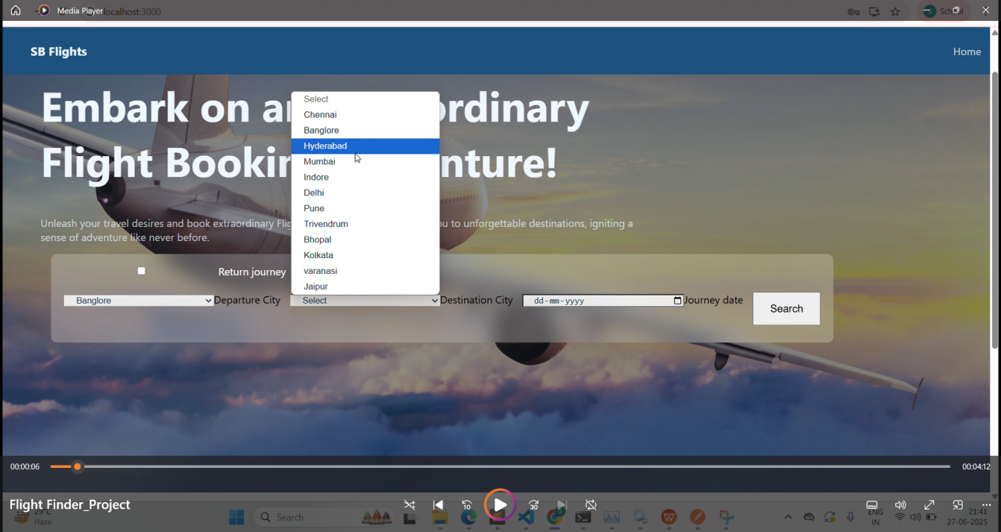

Login/Registration page

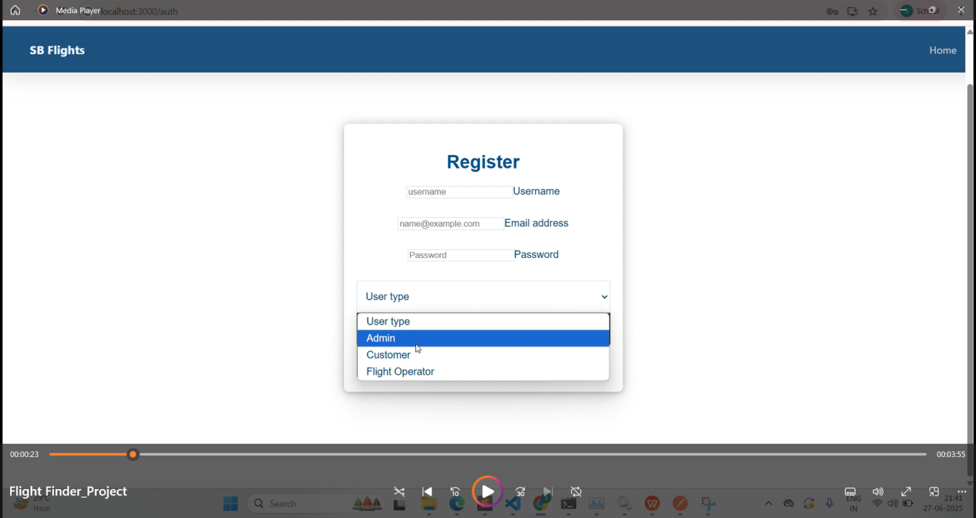

Booking confirmation page

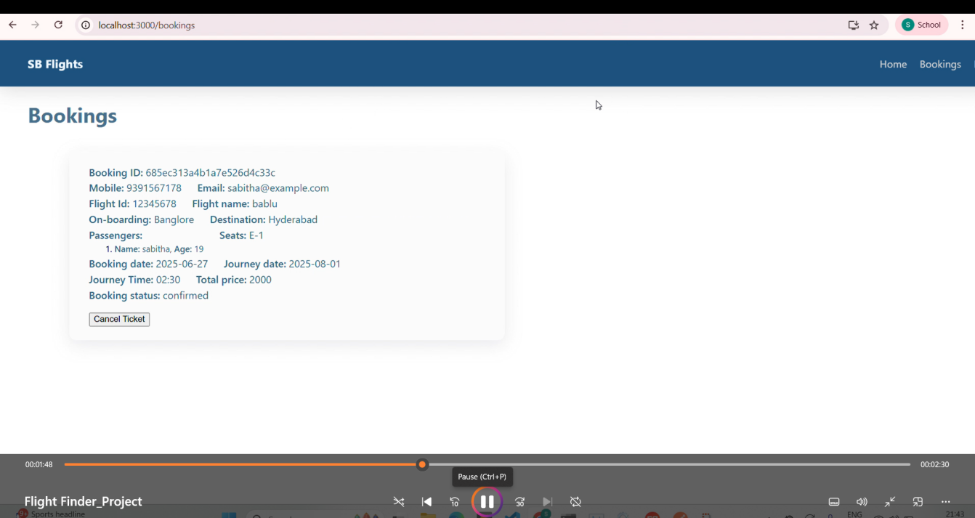

Admin dashboard page

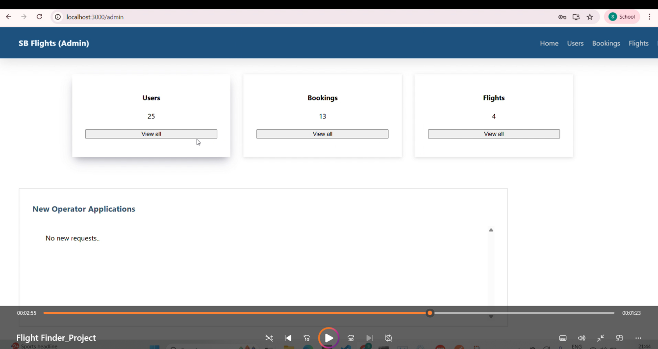

---

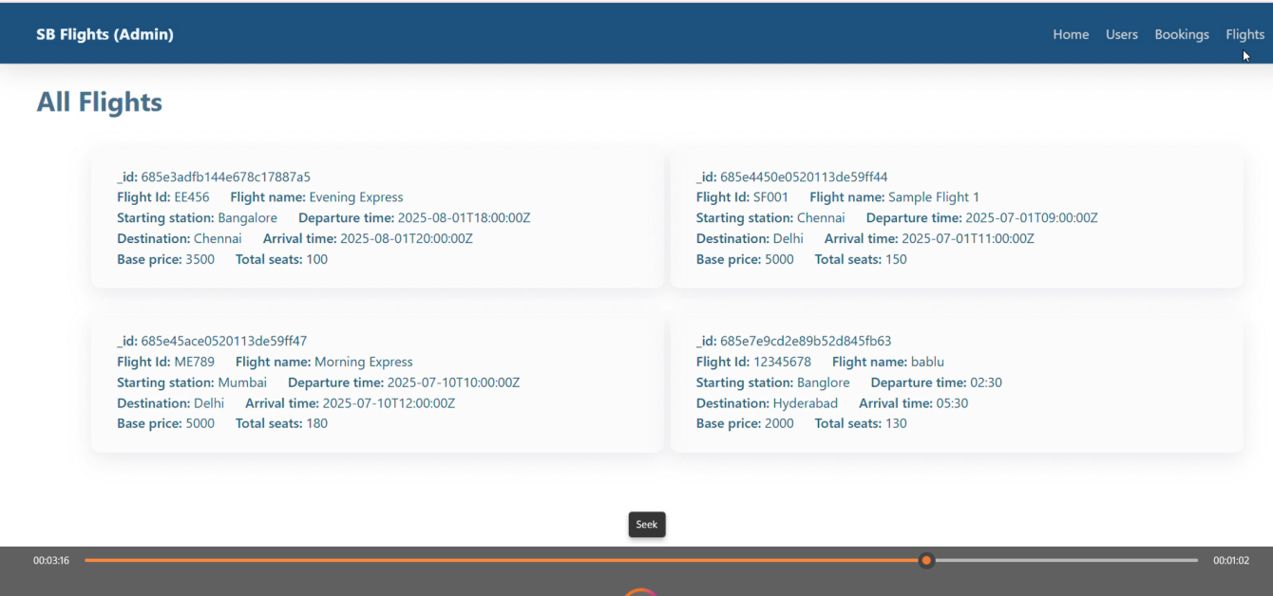

**8. ADVANTAGES & DISADVANTAGES**

**Advantages:**

1.Easy-to-use interface

2.Real-time flight data

3.Saves time for users

4.Secure booking flow

**Disadvantages:**

1.Requires reliable internet connection

2.Initial data sourcing may depend on airline APIs

**9. CONCLUSION**

FlightFinder simplifies air travel booking by providing a one-stop solution. The project is easy to use, scalable, and solves real user pain points by streamlining flight search, booking, and management.

**10. FUTURE SCOPE**

1.Fare prediction using ML

2.Personalized flight recommendations

3.Hotel & cab integration

1. Mobile app version

**11. APPENDIX**

**GitHub Link:** https://github.com/geetharani543/Flight-finder-navigating-your-air-travel-options

**Project Demo link:**

https://drive.google.com/file/d/1RJUFcKnNVVnpVJlMKfrVomsI08Um2t4a/view?usp=sharing